**Practical 01**

Demonstration of Linear Regression

**Code:**

import numpy as np

import matplotlib.pyplot as plt

def estimate_coef(x, y):

    # number of observations/points

    n = np.size(x)

    # mean of x and y vector

    m_x = np.mean(x)

    m_y = np.mean(y)

    # calculating cross-deviation and deviation about x

    SS_xy = np.sum(y*x) - n*m_y*m_x

    SS_xx = np.sum(x*x) - n*m_x*m_x

    # calculating regression coefficients

    b_1 = SS_xy / SS_xx

    b_0 = m_y - b_1*m_x

    return (b_0, b_1)

def plot_regression_line(x, y, b):

    # plotting the actual points as scatter plot

    plt.scatter(x, y, color = "m",

    marker = "o", s = 30)

    # predicted response vector

    y_pred = b[0] + b[1]*x

    # plotting the regression line

    plt.plot(x, y_pred, color = "g")

    # putting labels

    plt.xlabel('x')

    plt.ylabel('y')

    # function to show plot

    plt.show()

def main():

    # observations / data

    x = np.array([0, 1, 2, 3, 4, 5, 6, 7, 8, 9])

    y = np.array([1, 3, 2, 5, 7, 8, 8, 9, 10, 12])

    # estimating coefficients

    b = estimate_coef(x, y)

    print("Estimated coefficients:\nb_0 = {} \

    \nb_1 = {}".format(b[0], b[1]))

    # plotting regression line

    plot_regression_line(x, y, b)

main()

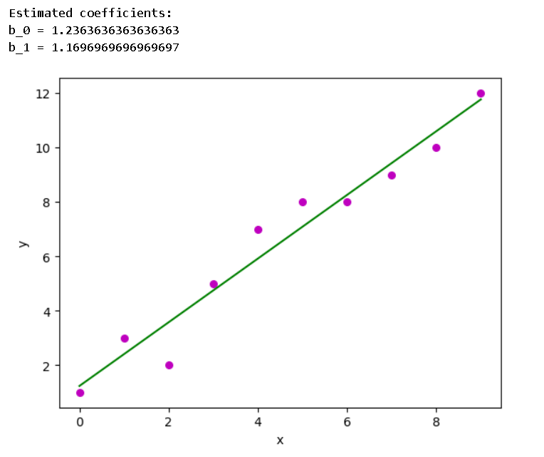

**Practical 02**

Demonstration of Logistics Regression.

**Code:**

X<-read.csv("C:/Users/Admin/Documents/SampleStudentData.csv")

> X

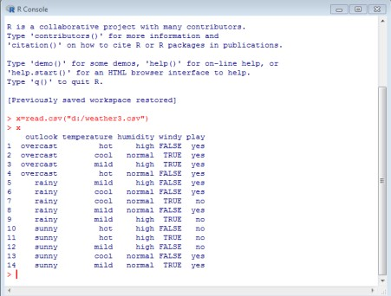

**PRINTING THE DATASET**

>x$humidity=ifelse(test=x$humidity=="high",yes=1,no=0) >x

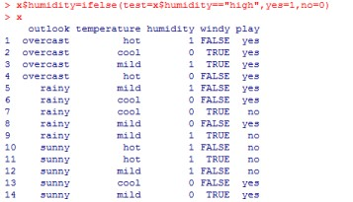

# >x$play=ifelse(test=x$play=="yes",yes=1,no=0) >x

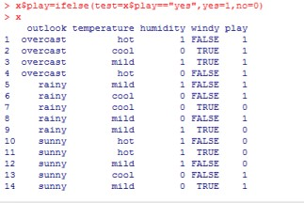

# >x$windy=ifelse(test=x$windy=="FALSE",ye s=0,no=1) >x

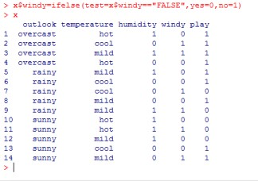

**PARTIONING DATASET**

> s=sample(nrow(x),.7*nrow(x))

>x_tr=x[s,]

>x_test=x[-s,]

>nrow(x)

>nrow(x_tr)

>nrow(x_test)

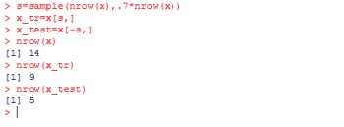

**DATA MODELING**

>lmod=glm(play~windy,data=x_tr,family=binomial,control=list( maxit=100)) >lmod

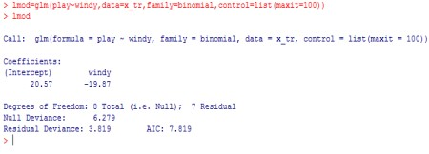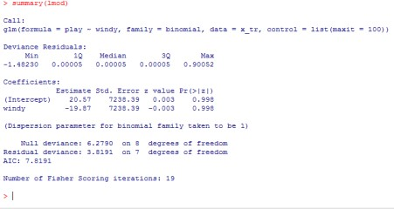

>lmod=glm(play~humidity,data=x_tr,family=binomial,control=list( maxit=100)) >summary(lmod)

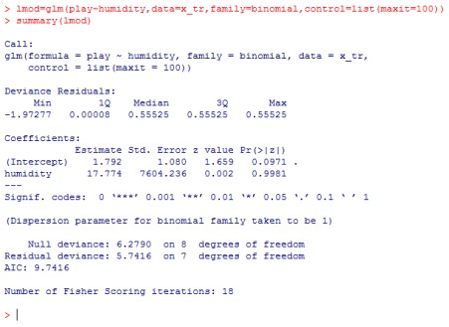

>lmod=glm(play~temperature,data=x_tr,family=binomial,control=list(maxit=100

)) >summary(lmod)

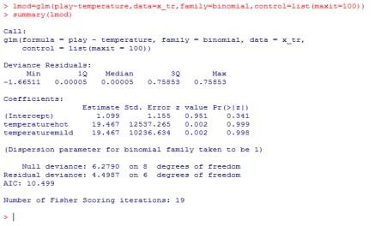

**#PREDICTION:**

> p=predict(lmod,x_test,type="response") >p

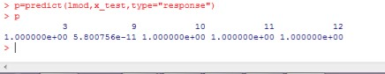

# (2) SECOND DATA SET: #IMPORT THE DATA

>x2=read.csv("D:/grade_logit.csv")

>x2

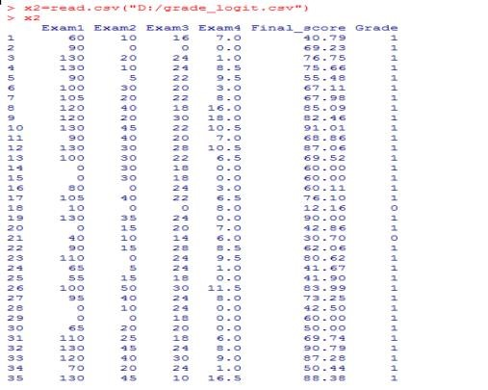

> lmod2=glm(Grade~Exam1,data=x2_train,family=binomial,control=list(maxit=100)) >summary(lmod2)

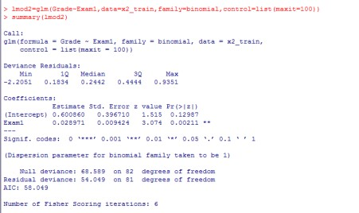

# Prediction data 1’s and 0’s form

>prediction=ifelse(p>.5,1,0)

>prediction

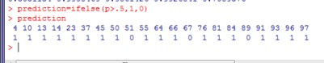

# PREDICTION MATRIX

>table(x2_test$Grade,prediction)

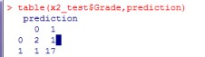

> x2_test

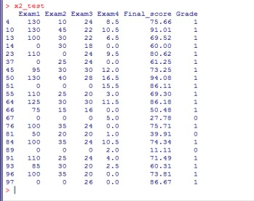

## #actuals predicted

>ac_pr<- data.frame(cbind(actuals=x2_test$Grade, predicteds=prediction)) >ac_pr

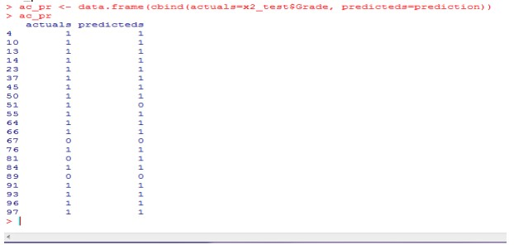

## >vif(lmod2) // variable influence factor

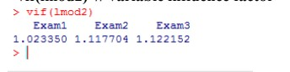

**Practical 03**

**Aim:** Demonstration of Hypothesis testing.

**Step 1:** First we have to create Excel file and Enter the 28 values so that we can fine deviation, Square of deviation, population, differentiate of mean, T-value, and system calculate standard deviation and save as **.**CSV file.

**Output:**

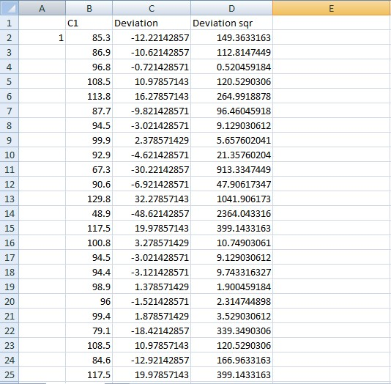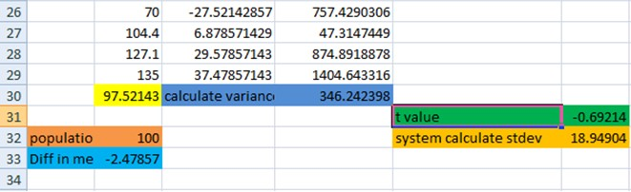

**Step 2:**Now we have to import Excel file (onetest.csv) type bellow command.

#datanew=read.csv("D:/onettest.csv")

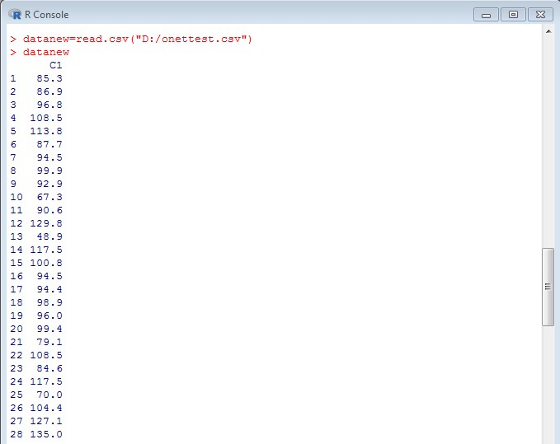

**Step 3:** After importing onetest.csv file we will plot Boxplot diagram type bellow command.#boxplot(datanew) **Output:**

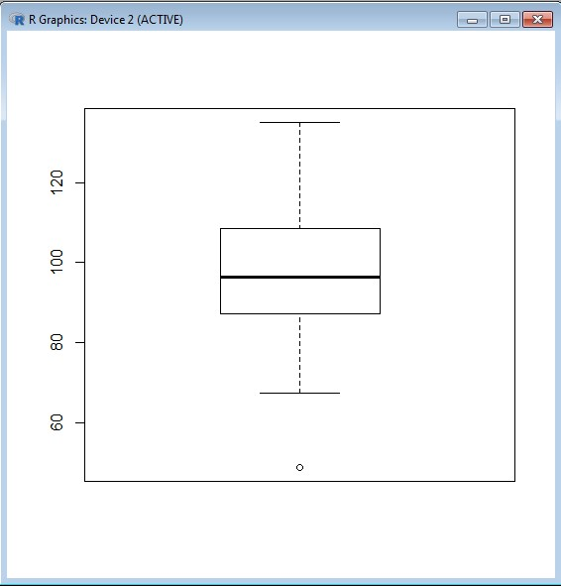

**Step 4:**After that find mean of respective data.

# m1=mean(datanew$C1)

#m1

**Output:**



**Step 5:**Now calculate the standard deviation.

#sd1=sd(datanew$C1)

#sd1

**Output:**

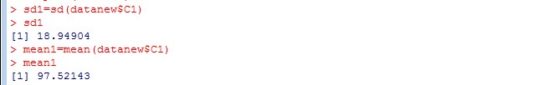

**Step 6:**Plot bell curve.

# plot(datanew$C1)

**Output:**

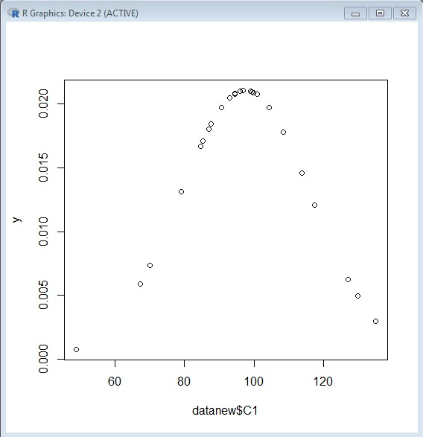

**Step 7:** At the end find T-Test value type following command.

#t.test(datanew$C1,alternative="greater",mu=100)

**Output:**

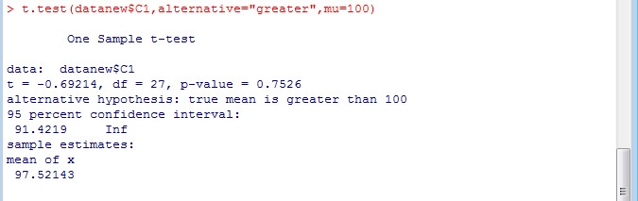

**Practical No 4**

**Aim:** Demonstration of Analysis of Variance.

Code: **# CREATE THE DATA IN TO THREE GROUPS**

### #TO PRINT THE BOXPLOT

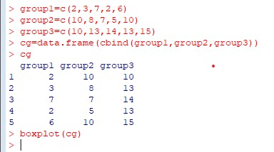

**BOXPLOT**

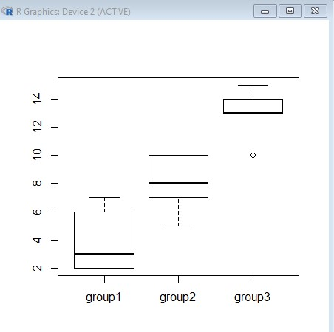

### #TO PRINT THE DATA INTO STACK FORMATE

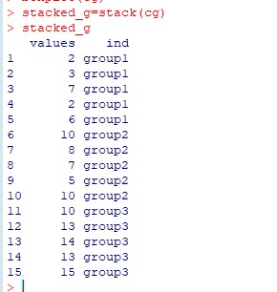

**TAKE ANOTHER DATASET AND WORK ON THAT.**

### # CREATE THE DATA IN TO THREE GROUPS

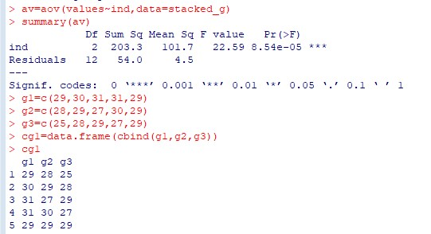

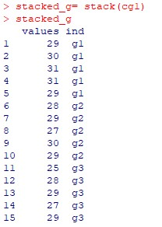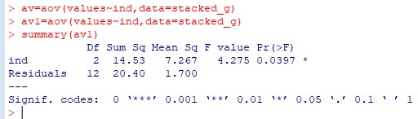

**Practical 05**

Aim: Demonstration of Decision Tree

**Steps:**

Step1: click on packages and set cran mirror.

Step2: click on packages and select install packages and install 3 packages (rpart,tree,rattle)

Step3:(OPTIONAL Application for version 4.2 ) install.packages("rpart") install.packages("tree") install.packages("rattle")

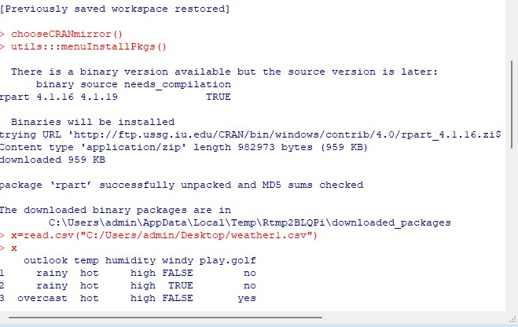

Step4: **Create an excel data save it with .csv extension.**

**Code:**

**Read excel data in rstudio**

> x=read.csv("C:/weather1.csv")

> x

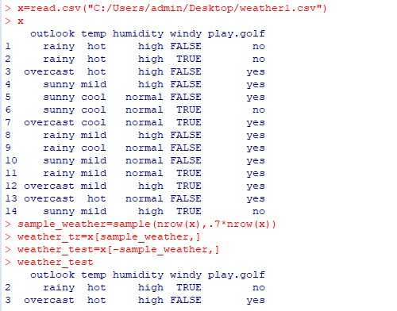

**Create sample partition of the excel data**

> sample_weather=sample(nrow(x),.7*nrow(x))

**Create a weather partition for training** > weather_tr=x[sample_weather,]

**Create a weather partition for testing**

> weather_test=x[-sample_weather,]

> weather_test

**Call rpart packages**

> library(rpart)

> library(rpart.plot) **Plot tree**

dtreemod=rpart(play.golf~.,data=weather_tr,method="class",control=rpart.control(minsplit=1,min bucket=1)) rpart.plot(dtreemod)

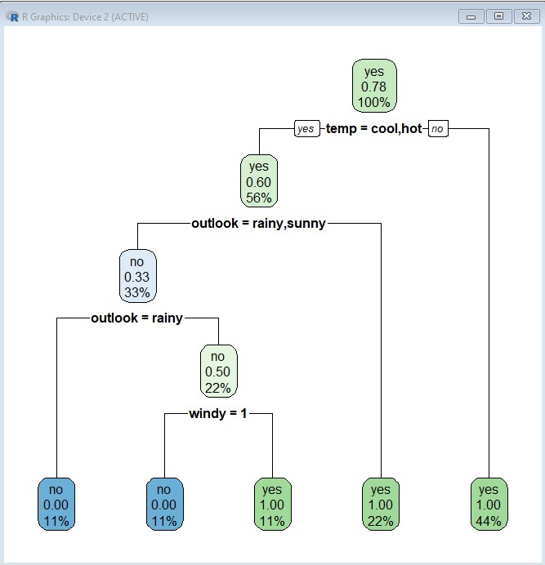

**Predict Tree:**

> p=predict(dtreemod,weather_test,type="class")

> weather_test

> table(weather_test$play.golf,p)

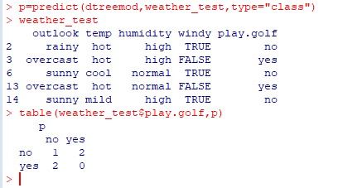

**Printing rules with rpart.rules** rpart.rules(dtreemod)

play.golf

0.00 when temp is hot

1.00 when temp is cool or mild

>

**Regression Tree:**

> x2=read.csv("C:/Users/admin/Desktop/weather2.csv")

> x2

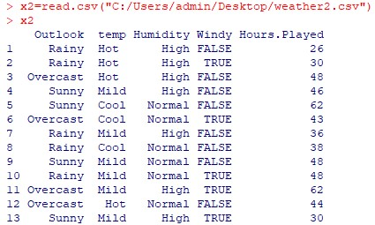

weather_tr2=x2[S2,] > s2=sample(nrow(x),.7*nrow(x)) > weather_tr2=x2[s2,]

> weather_test2=x2[-s2,] > weather_test2

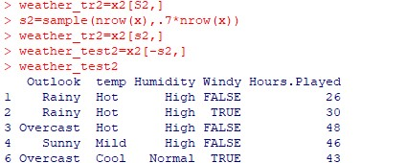

dtreemod2=rpart(Hours.Played~.,data=weather_tr2,method="anova",control=rpart.control(minsp lit=1,minbucket=1)) > rpart.rules(dtreemod2)

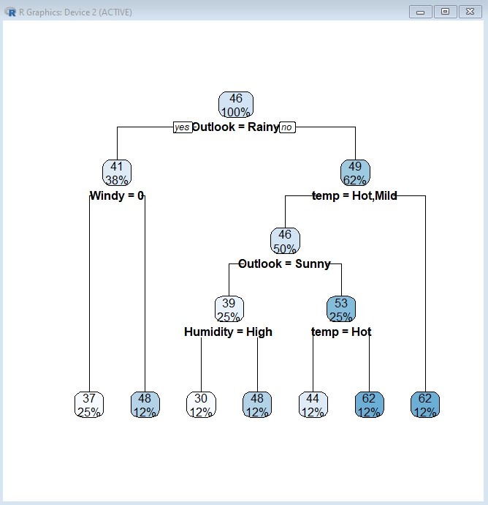

**Prediction:**

> actuals_preds<- data.frame(cbind(actuals=weather_test2$Hours.played,predicts=p))

> actuals_preds

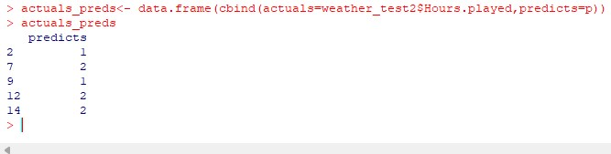

**Practical 06**

**Aim:** Demonstration of Principal Component Analysis. **Steps:**

Step1: click on packages and set cran mirror(click on other and select USA IN) Step2: click on packages and select install packages and install package FactoMineR.

**install.packages("FactoMineR") library(FactoMineR)** Step3: Create Excel Sheet.

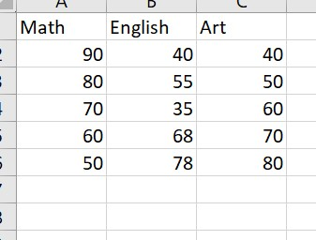

**Code:**

x=read.csv("C:/Users/Akki/OneDrive/Desktop/JEENAL/students.csv") x

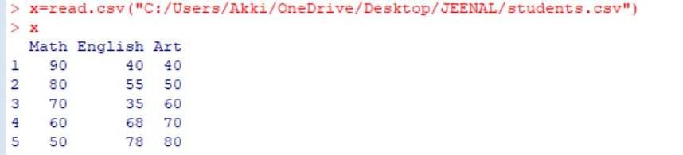

cov_mat=cov(x) cov_mat

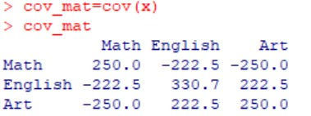

ex=eigen(cov_mat) ex

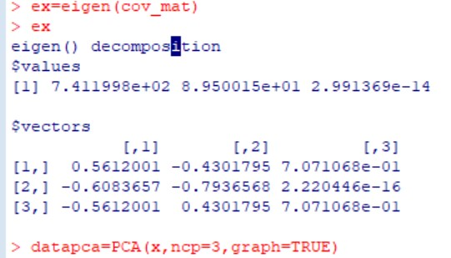

datapca=PCA(x,ncp=3,graph=TRUE)

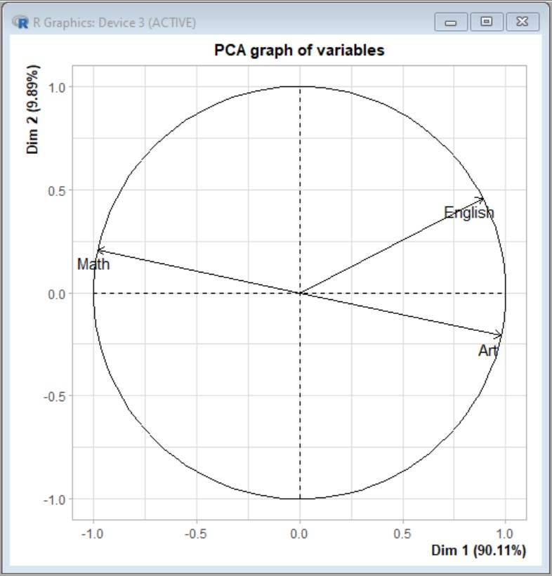

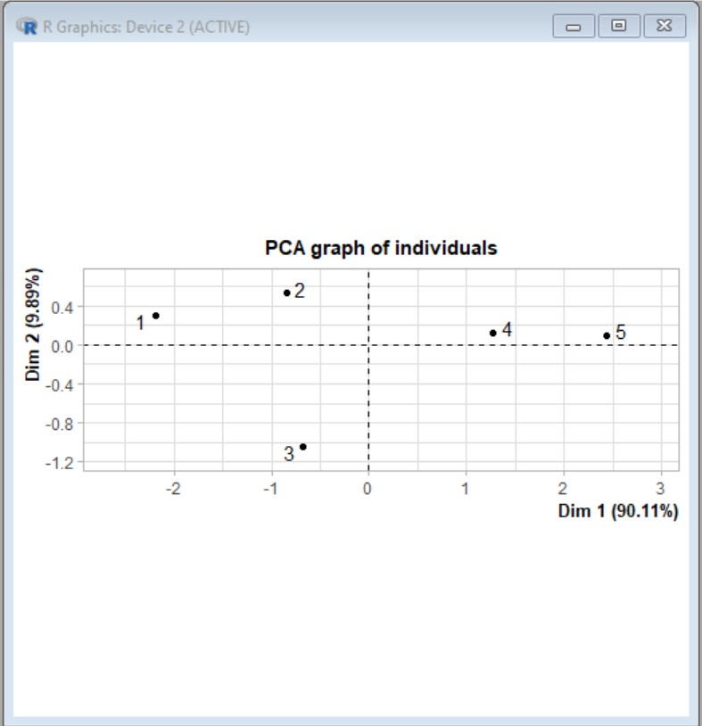

datapca$eig

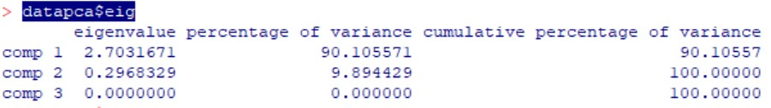

datapca$var

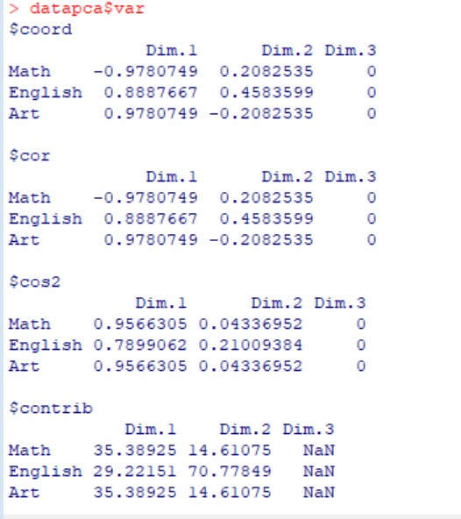

datapca$var$coord

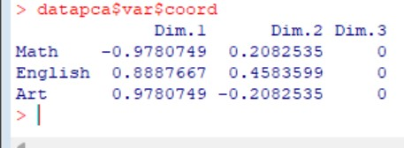

fviz_screeplot(datapca,addlabels=TRUE,ylim=c(0,50))

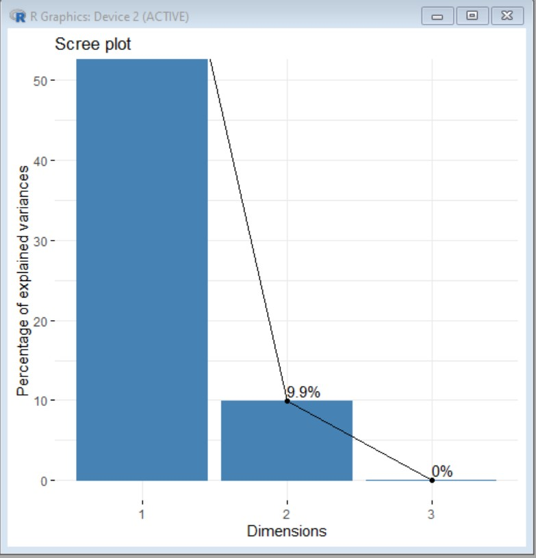

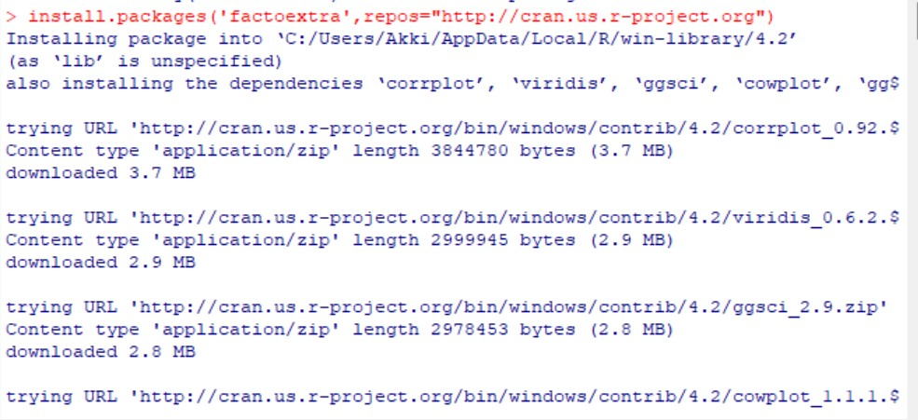install.packages('factoextra',repos="<http://cran.us.r-project.org>") library("factoextra") fviz_screeplot(datapca,addlabels=TRUE,ylim=c(0,50)) head(iris) x=iris[,-5]

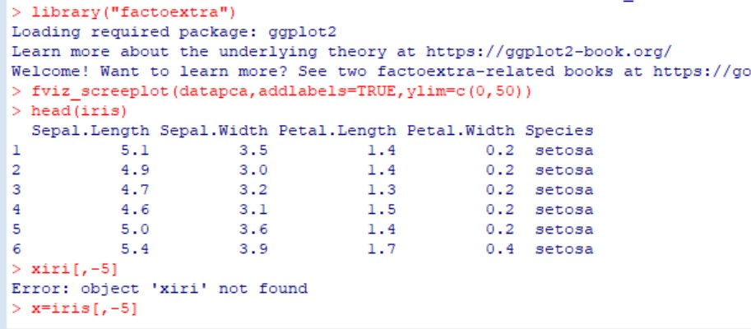

x=iris[,-5] x

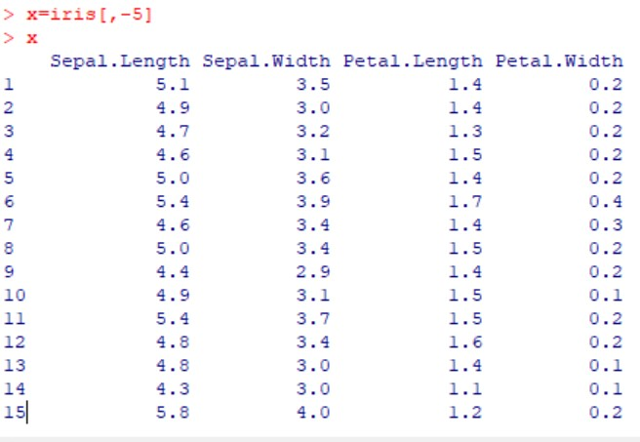

cov_iris=cov(x) cov_iris

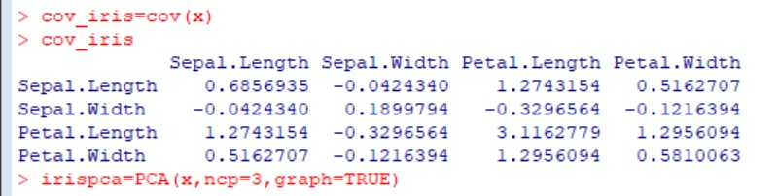

> irispca=PCA(x,ncp=3,graph=TRUE)

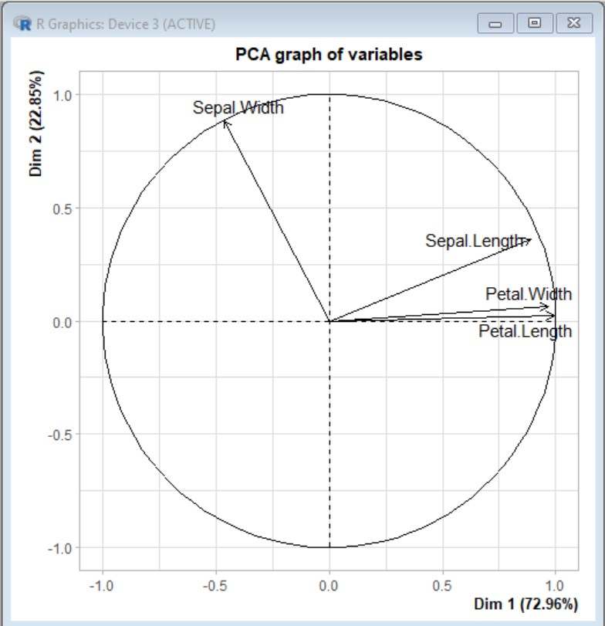

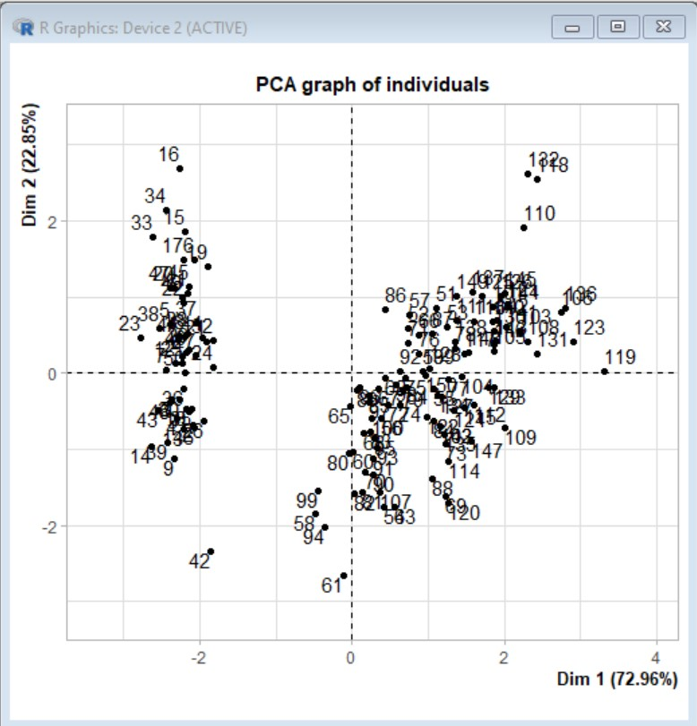

irispca

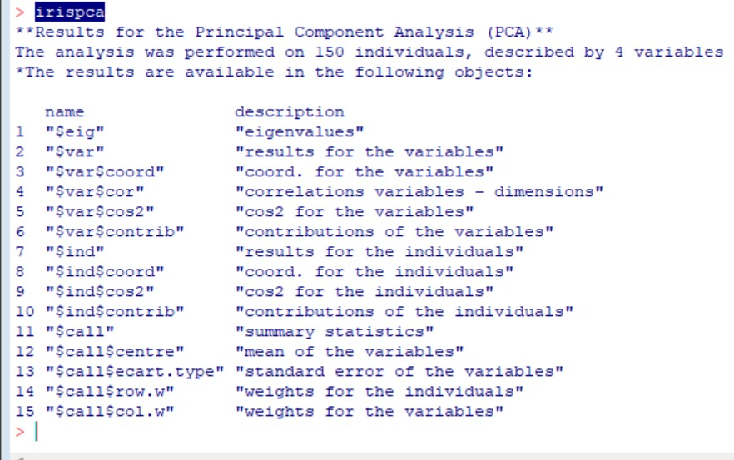

summary(irispca)

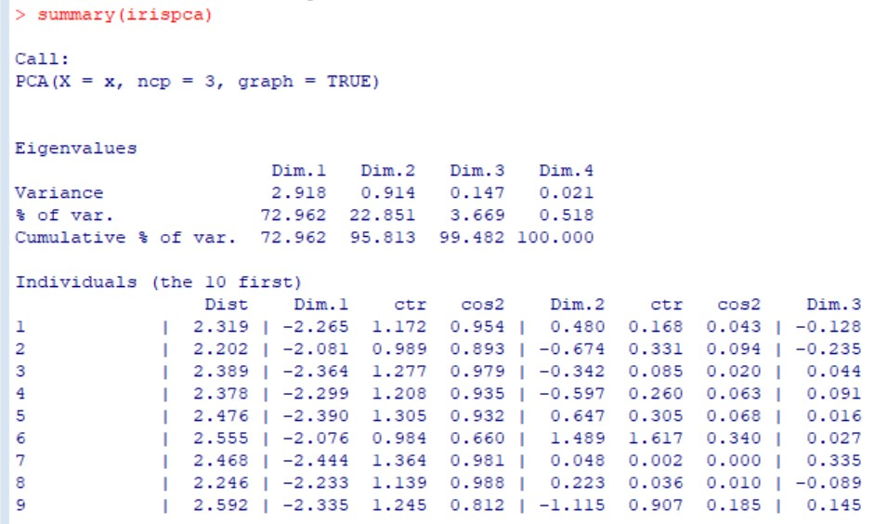

**Practical 07 Aim:** Demonstration of Clustering df=read.csv("C:/Users/admin/Documents/AGE.csv") df

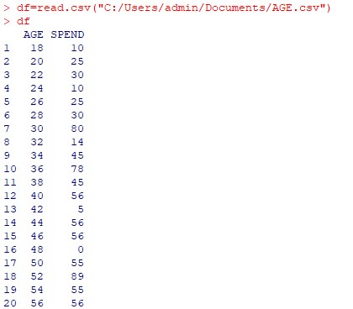

plot(df)

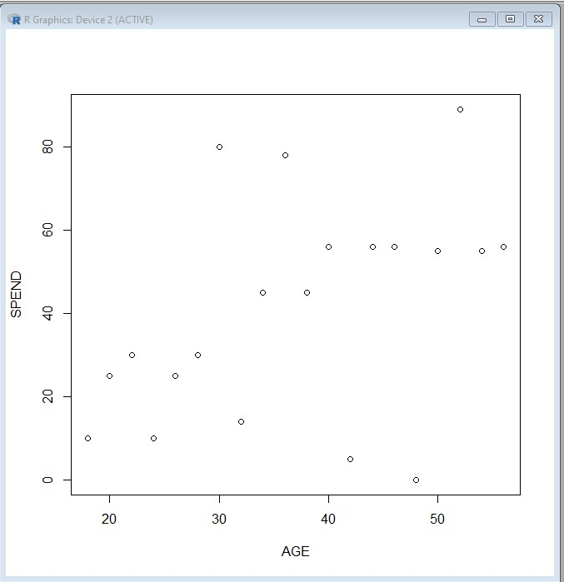

boxplot(df)

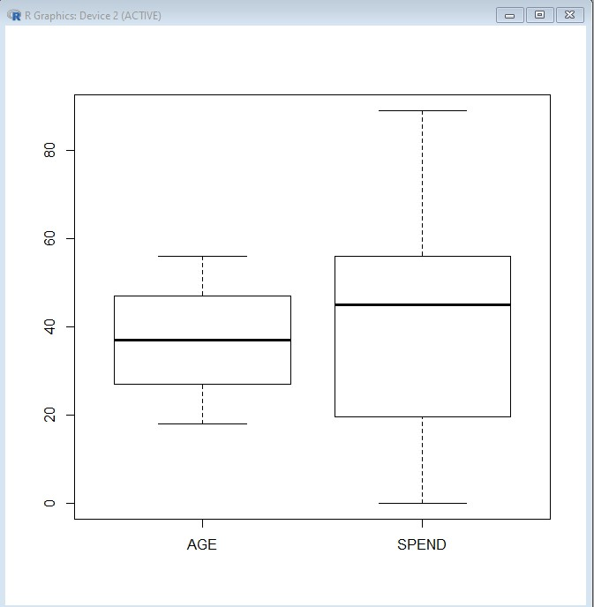

### Make the cluster

>set.seed(20)

> c1=kmeans(df[,1:2],3)

> c1

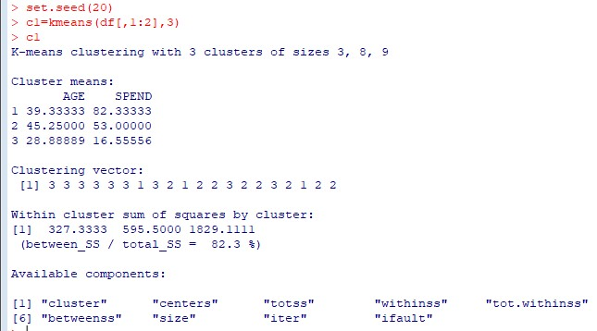

**#SHOW THE IRIS DATA SET**

>iris

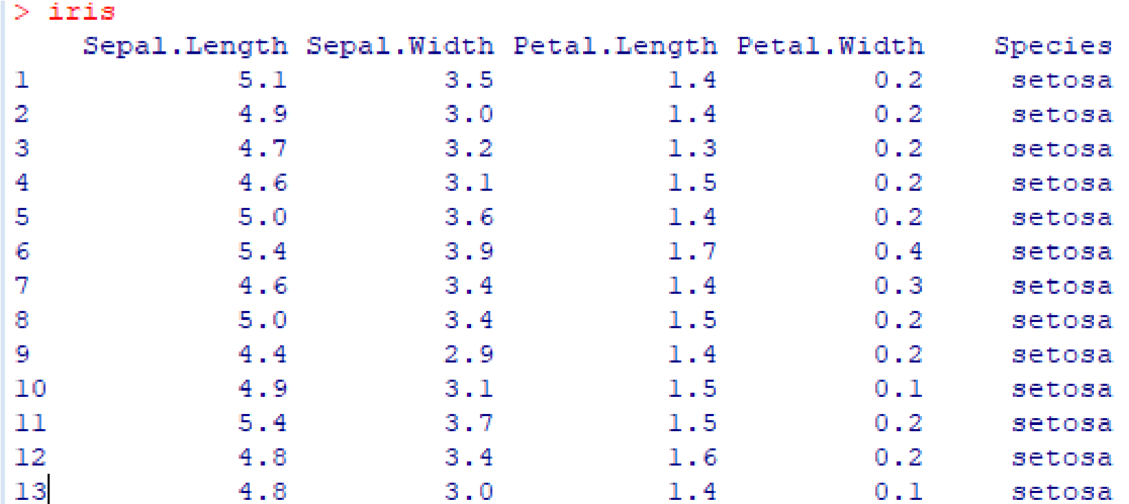

#View(iris)

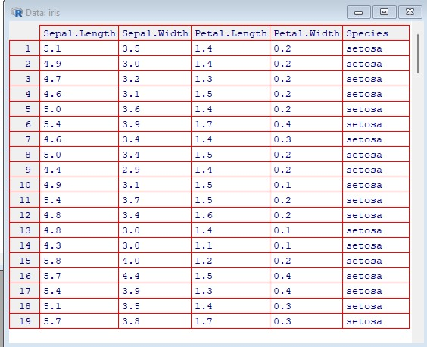

head(iris) summary(iris)

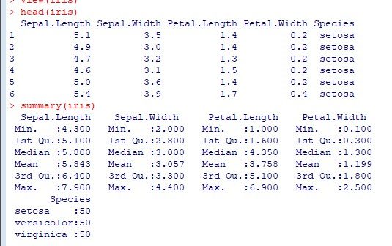

plot(iris)

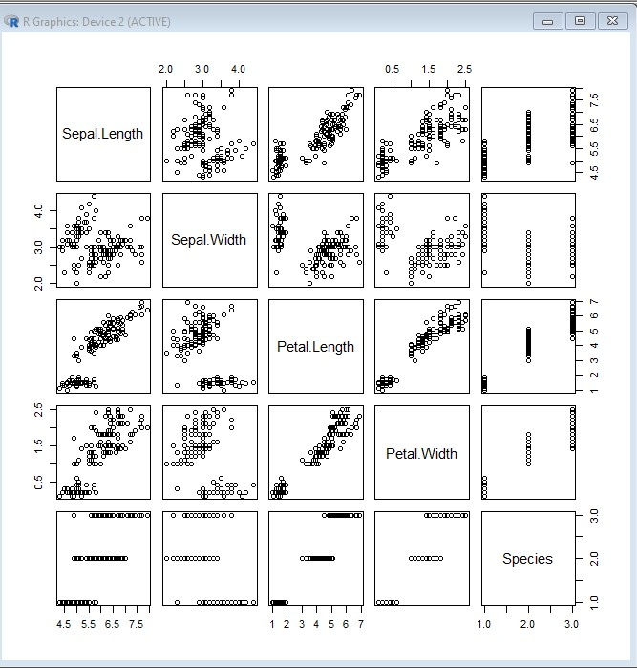

plot(iris[,3:4])

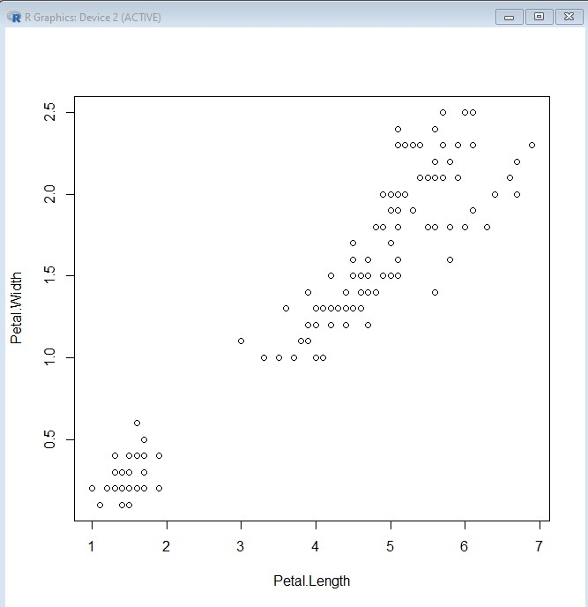

kmeansc1=kmeans(iris[,3:4],3) kmeansc1

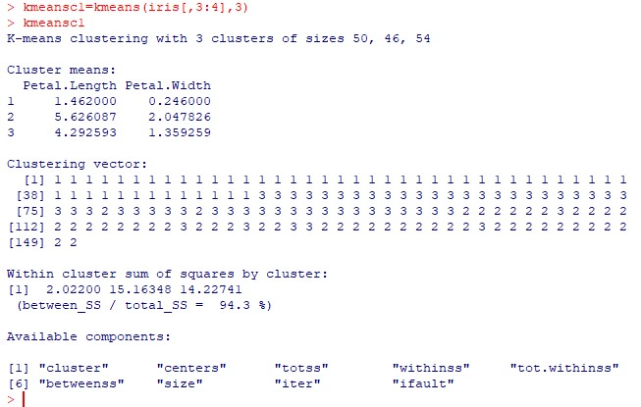

### PRINT CONFUSION MATRIX

>table(kmeansc1$cluster,iris$Species)

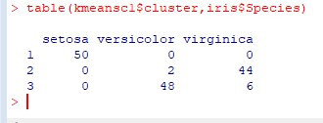

**CALCULATION OF ACCURACY 94.6%**

boxplot(iris)

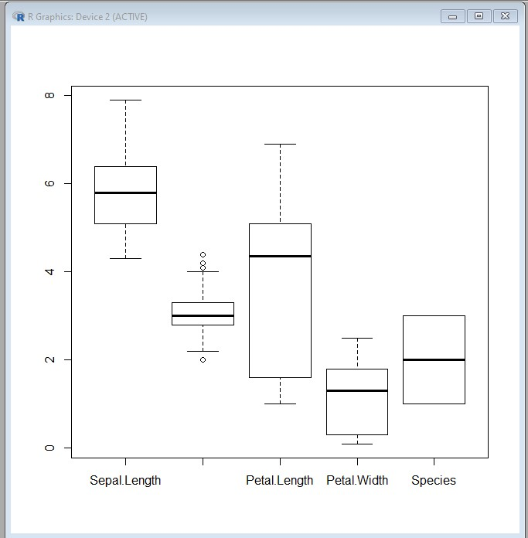

**Practical No 8**

#### Aim: Demonstration of Time-series forecasting. STEP 1: Install time series install.packages(“timeSeries”)

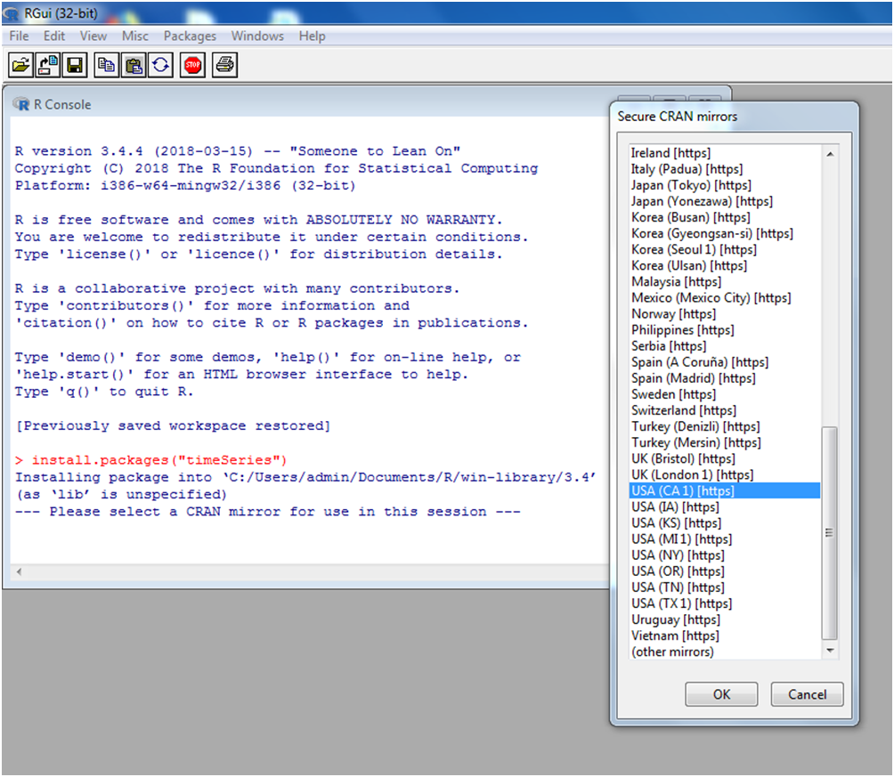

#### Step 2: Install package forecast install.packages(“forecast”)

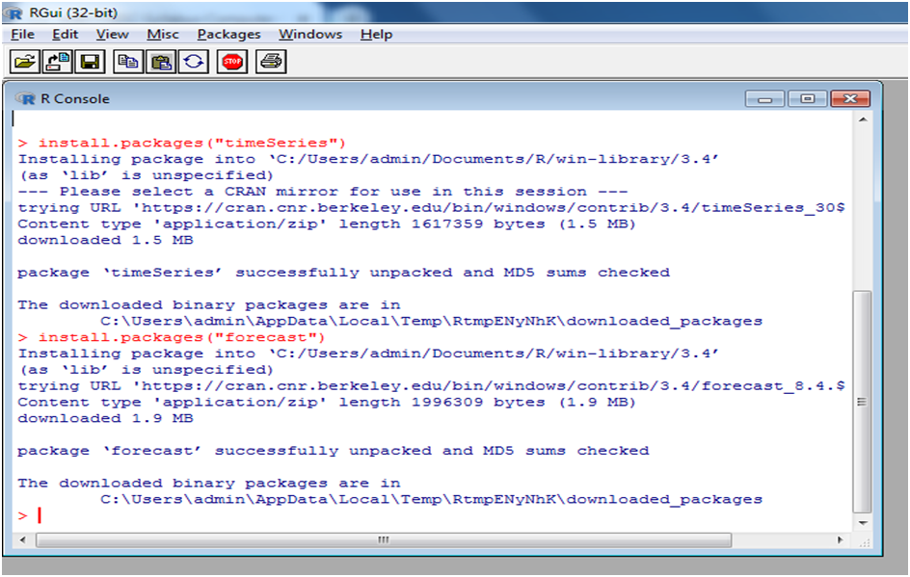

data1=table(AirPassengers) Data1 view(data1)

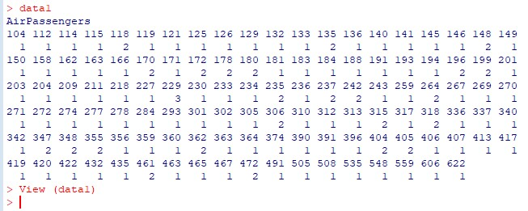

**Step 3:** library (timeSeries)

#library(forecast)

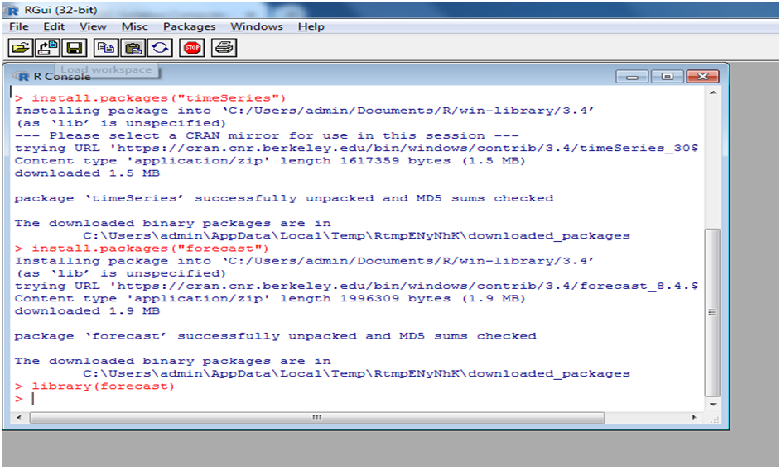

library(forecast)

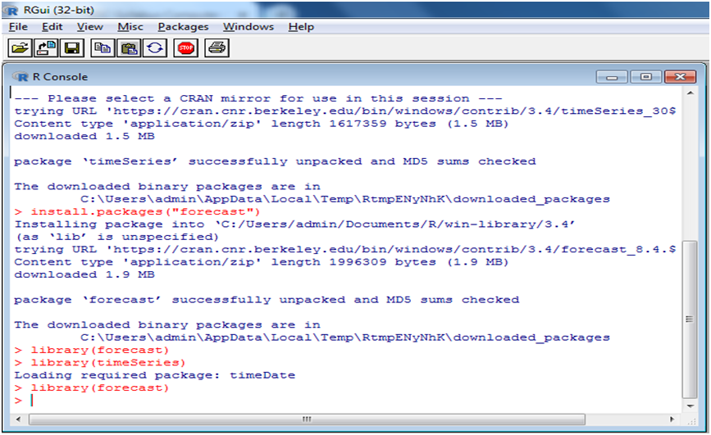

Step 5: Air Passengers data data1=table(AirPassengers) data1

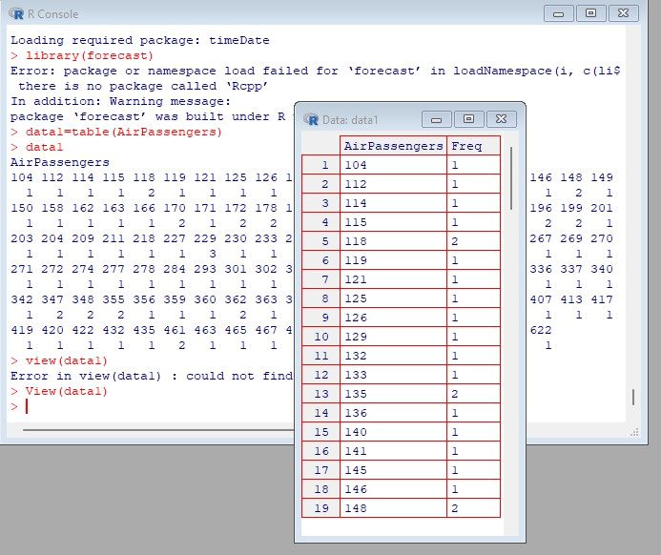

frequency (AirPassengers)

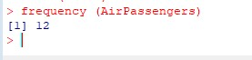

tsdata=ts(AirPassengers,frequency=12)

> tsdata

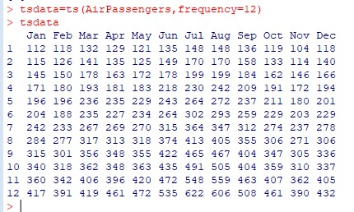

plot(tsdata)

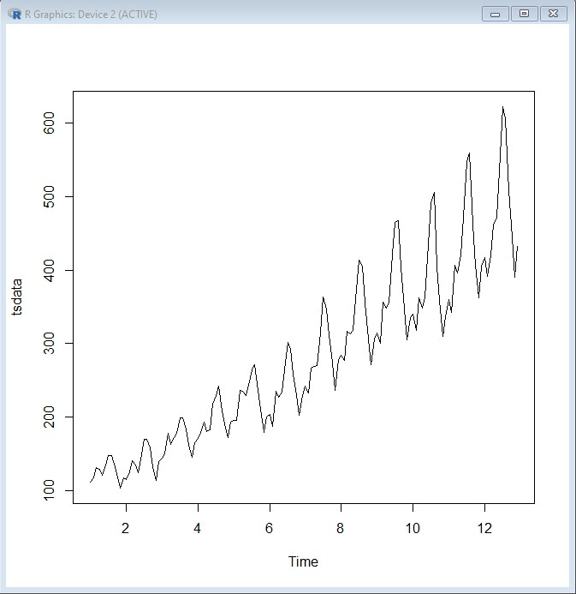

> d=decompose(tsdata,"multiplicative")

> plot(d)

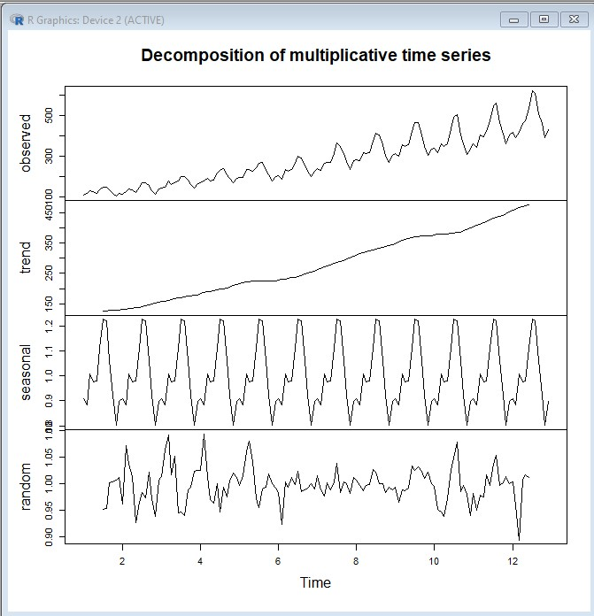

plot(d$trend)

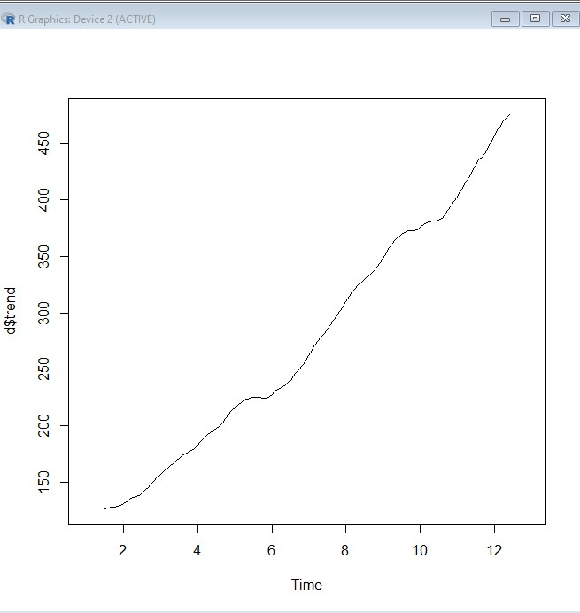

plot(d$random)

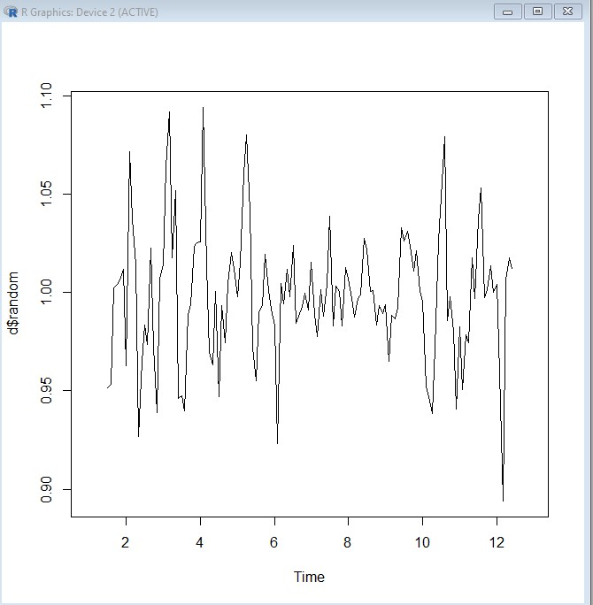

plot(d$seasonal)

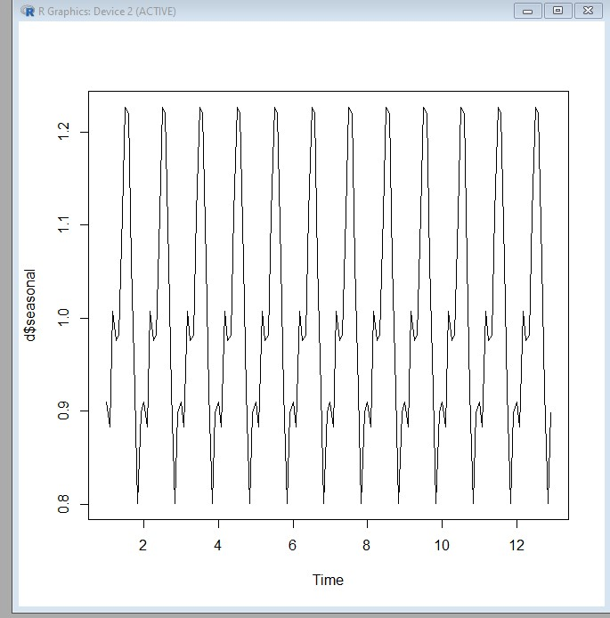

boxplot(AirPassengers~cycle(AirPassengers,xlab="date",ylab="passengers count in 1000",main="monthly box plot"))

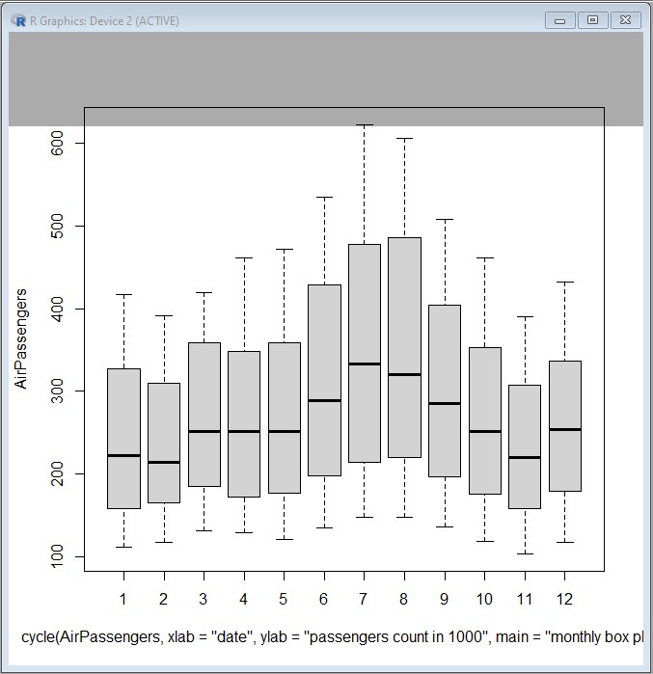

mymodel<- arima(AirPassengers) mymodel

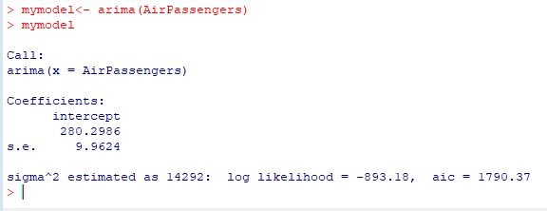

**Practical 09**

Procedure:

Starting server with mongo or mongodb

C: \ >mongo >db Test

• Create Database In MongoDB

Once you are in the MongoDB shell, create the database in MongoDB by typing this command:

use database_name

For example: create a database “tycs”:

> use tycs switched to db tycs

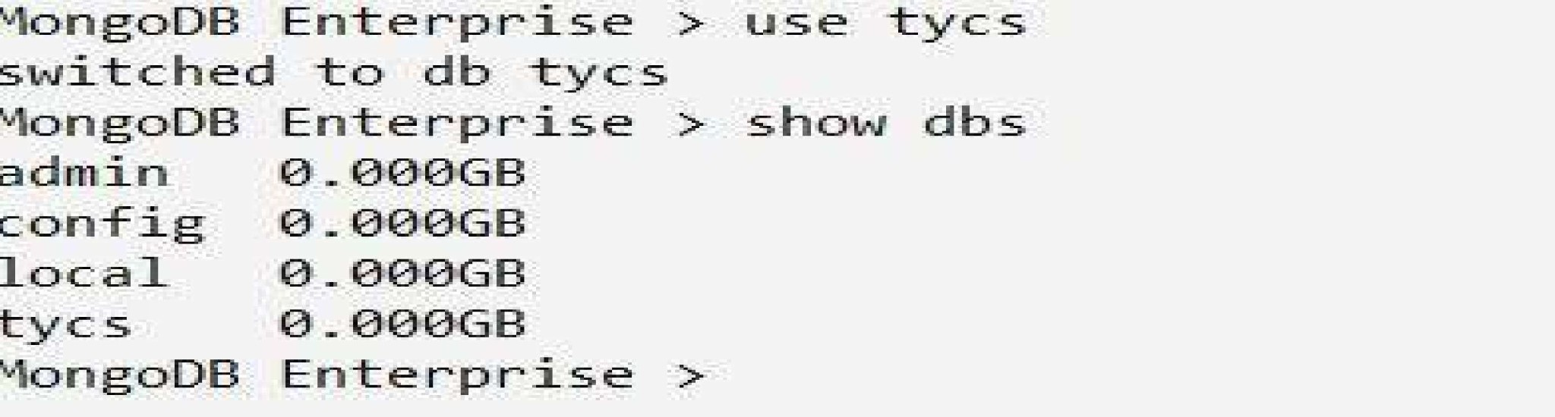

create a collection user and insert a document in it.

> db.user.insert((name: "Asif", age: 20})

O/P: WriteResult(( "nInserted" : 1 })

>showdbs

admin 0.000GB config 0.000GB local 0.000GB tycs 0.000GB

* MongoDB Drop Database



O/P:

( "dropped" : "Testdb", "ok" : 1 } MongoDB Enterprise > show dbs

admin 0.000GB

config 0.000GB local 0.000GB tycs 0.000GB O/P:

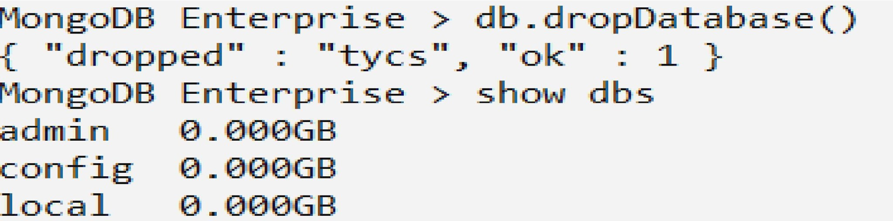

* Create Co1Iect1ozz 1zz MozzgoDB

Method 1: Creatlng the Collection 1n MongoDB on the fly

MongoDB Enterprise > use tycs

switched to db tycs

MongoDB Enterprise > db.tycs.insert((name:"Asif khan",age:21,website:"www.goog1e.com"})

WriteResult(( "nInserted" : 1 })

Syntax: db.co1leetion_name.find{J

MongoDB Enterprise > db.tycs.find()

o/p:

( "_id" : ObjectId("5e410808e3755b1e06a63d1d"), "name" : "Asif khan", "age" : 21, "website" : "www.google.com" }

show collections

MongoDB Enterprise > show collections

O/P:

tycs

user

##### • Drop collection Ie MongoDB

SYNTAX:

db.co11ection_name.drop()

MongoDB Enterprise > use students

switched to db students

MongoDB Enterprise > show collections students teachers tycs user

MongoDB Enterprise > db.user.drop{J true MongoDB Enterprise > show collections students teacher

tycs

MongoDB Insert Document

Syntax to insert a document into the collection:

##### db.collection_name.insert()

> db.tycs.insert{

zzazzze: "ASIE’", age:

20,

email: "as1f@gmai1.com",

... course: [ ( zzame: "MozzgoDB", durataozz: 7 }, ( zzame: "Java", duration: 30 } ]

O P:

WriteResult(( "nInserted" : 1 })

>

db.tycs.find{J



( " id" : Objectld("5c2d37734fa204bd77e7fc1c"), "name" : "ASIF", "age" : 20, "email" : "asif@gmail.com", "course" : [ { "name" :

"MongoDB", "duration" : 7 }, { "name" : "Java", "duration" : 30 } ] }

MongoDB Example: Insert Multiple Documents in collection

MongoDB Enterprise > var beginners=

... "studentID": 1001,

... "studentName":"Asif",

... "age":20

* MongoDB Query Document using fiiid{J method

Querying all the documents in JSON format

MongoDB Enterprise > db.students.find().pretty()

"_id" ObjectId("5e4l0f3fe3755ble06a63d1e"),

"studentID" : 1001,

"studentName" : "Asif", "age"

: 20

* Quezy Document based on tfze criteria

> db.students.find({StudentName "Asif'}).pretty()

"_id" ObjectId("5c28lc90c23e08d l5l5fd9cc"),

"Studentld" : 1001,

"StudentName" : "ASlf",

"age" : 20

###### • Updating Document using update() method



db.co11ection_name.update(criteria, update_data)

> use tycs switched to db tycs > sbow co11ectlozzs beginnersbook students tycs

> db.createCol1eetion{"got"} (

"ok" : 1 }

> var abc = [

"_id" ObjectId("59bd2e73ce524b733fl4dd65"), "name"

"Asifi",

"age" 20

> db.got.find(J.pretty(J

" id" Objectld("59bd2e73ce524b733fl4dd65"),

"name" : "steve",

"age" : 20

To update multiple documents with the update{} method:

##### db.got.update(("name":"Jon Snow"}, ($ set :("name":"Kit Harington"}},(multi:true})

Updating Document using save() method Syntax:



)

##### db.got.find().pretty()

> db.got.find(("name”: "Asifi'}).pretty()

"did" Objectld("59bd2e73ce524b733fl4dd65"),

"name" : "Asifi’,

"age" : 20

> db.got.find().pretty()

"_id" ObjectId("59bd2e73ce524b733fl4dd65"),

"name" : "Steve",

"age" : 20

• MongoDB Delete Document from a Collection

Syntax of remove(J method:



##### db.collection_name.remove(de1ete_criteria)

Delete Document using remove{J method

|  |
| --- |
| > db.students.find().pretty()    " id" ObjectId("59bcecc7668dcce02aaa6fed"),  "Studentld" : 1001,  "StudentName" : "Steve",  "age" : 30 |



|  |
| --- |
| WriteResult(( "nRemoved" : 1 }) |

To verify whether the document is actually deleted. Type the following command:



> use tycs switched to db tycs

> db.students.find().pretty()

" id" Objectld("5c28lc90c23e08d15 l5fd9cc"),

"Studentld" : 1001,

"StudentName" : "Asif",

"age" : 20

"_id" ObjectId("5c2d38934fa204bd77e7fc1d"),

"Studentld" : 1001,

"StudentName" : "Steve",

"age" : 30

Remove all Documents

###### db.col1ection_name.remove(§)

• MongoDB Projection

Syntax:

##### db.co11ection_name.find(§,(fie1d_key:1 or 0})

> db.students.find().pretty()

"_id" Objectld("5c28lc90c23e08d15 l5fd9cc"),

"Studentld" : 1001,

"StudentName" : "Steve",

"age" : 20



> db.students.find(§, ("_id": 0, "StudentId" : 1}) (

"StudentId" : 1001 }

( "StudentId" : 1002 }

> db.students.find(§, ("_id": 0, "StudentName" : 0, "age" : 0}) ( "Studentld" : 1001 }

{ "Studentld" : 1002 }

• MongoDB — limit( J and ship{ J method The limit(J method in MongoDB

Syntax:

db.collection_name.find().limit(number_of_documents) db.studentdata.find((student_id ($gt:2002}}).pretty() db.studentdata.find((student_id ($gt:2002}}).limit(1).pretty()

]

##### db.studentdata.find((studentpid {$gt:2002}}).limit(1).skip(1).pretty()

MongoDB Sk1p() Method

• tongoDB aort() method

Sorting Documenta ualng aort() method

Syntax o£ sort() method:

##### db.col1ecttion_name.find().sort({field_key:1 or -1})

1 is for ascending order and -1 is for descending order. The default value 1s 1.

For example: collection studentdata contains following documents:

|  |
| --- |
| > db.studentdata.find().pretty()    "_id" ObjectId("59bf63380be ld7770c3982afi’), "student_name" : "Steve",  "student id" : 1001, "student age" :1002 |

Let’s display thelS tt ldent_id of all the documents in descending order

##### > db.studentdata.find(§, {"student_id": 1, _id:0}).sort({"student_id": -1})

( "student_id" : 1001 } ( "student_id" : 1002 }

To display the studentqid field of all the students in ascending order:

##### > db.studentdata.find(§, {"student_id": 1, did:0}).sort({"student_id": 1})

( "student_id" : 1001 }

( "student_id" : 1002 }

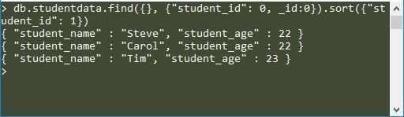

• MongoDB Indexing with Example How to create index in MongoDB

###### db.collection_name.createIndex((field_name: 1 or -1})

The value 1 is for ascending order and -1 is for descending order.

Let’s create the index on student_name field in ascending order:

###### db.studentdata.createIndex((student_name: 1})

Output:



• MongoDB — Finding the indexes in a collection

##### db.collection_name.getIndexes() > db.studentdata.getIndexes()



"v" 2,

"key" (

"_id" 1

"name" : " id ",

"ns" : "test studentdata"

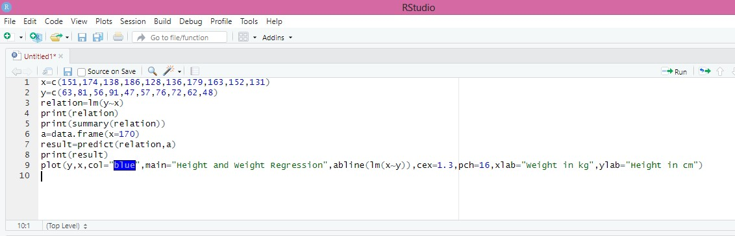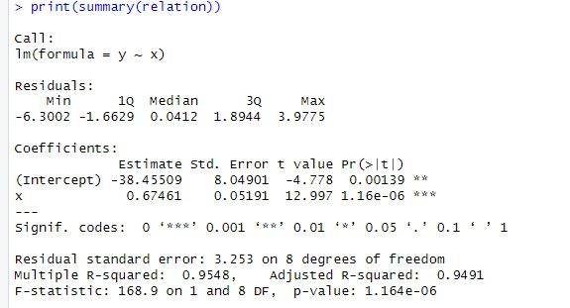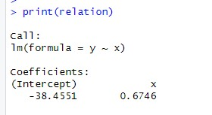

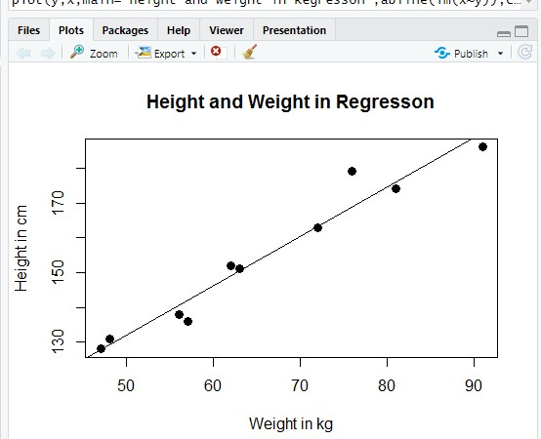

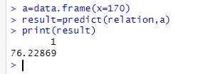

**Practical 10**

**Aim :**Demonstration of Clustering in R studio

